**CONTAINERIZING MICROSERVICE PROJECT**

AWS Microservices is a way of building and deploying software applications as a collection of small, independent services that work together to provide a larger application or system. Each microservice is designed to perform a specific business function and can be developed, tested, and deployed independently of the other services.

AWS provides a range of services that can be used to build and deploy microservices, including AWS Lambda, Amazon Elastic Container Service (ECS), Amazon Elastic Kubernetes Service (EKS), Amazon API Gateway, Amazon DynamoDB, and Amazon SQS.

With AWS microservices, applications can be built and deployed in a more agile and scalable way, as each service can be developed, tested, and deployed independently of the others. This means that new features can be added and deployed faster, and updates can be made without affecting the entire system.

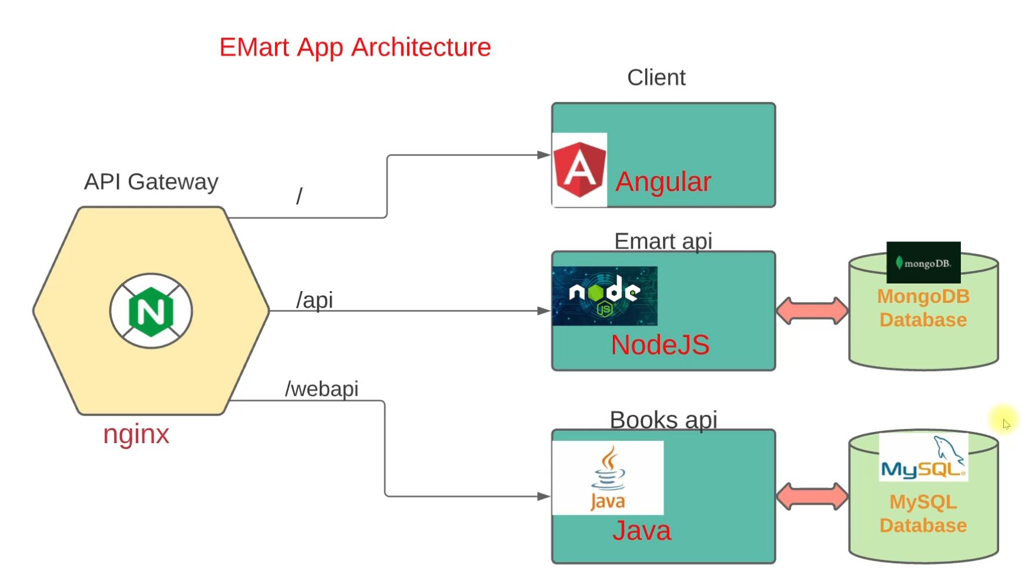

STEPS:

1. Go to GitBash and clone the Repository
2. mkdir –p /c/microsvc
3. cd /c/microsvc/
4. git clone https://github.com/devopshydclub/emartapp.git
5. ls
6. cd emartapp/
7. code **. (**Used to open the current working directory in Vs Code)
8. Go through the default.conf for: (Nginx) with the Vs Code
9. Go through the Dockerfiles for: (Nginx, Angular, NodeJS and Java) with the Vs Code
10. Go through the Docker-compose file for: (Nginx, Angular, NodeJS and Java) with the Vs Code
11. Go to your AWS account and click on Launch an Instance under EC2

* Name = DockerEngine
* AMI = Ubuntu 20.04
* Instance Type = t3.medium 4GB memory (There will be a charge. we need it for an hour)
* Create a key pair (name = dockerkey, RSA, .pem)
* Security Groups:

SSH / My IP

HTTP / Anywhere

* Storage size = 20GB
* click on Additional information for provisioning:

#!/bin/bash

# Install docker on Ubuntu

sudo apt-get update

sudo apt-get install \

ca-certificates \

curl \

gnupg \

lsb-release -y

curl -fsSL https://download.docker.com/linux/ubuntu/gpg | sudo gpg --dearmor -o /usr/share/keyrings/docker-archive-keyring.gpg

echo \

"deb [arch=$(dpkg --print-architecture) signed-by=/usr/share/keyrings/docker-archive-keyring.gpg] https://download.docker.com/linux/ubuntu \

$(lsb_release -cs) stable" | sudo tee /etc/apt/sources.list.d/docker.list > /dev/null

# Install docker-compose

sudo apt-get update

sudo apt-get install docker-ce docker-ce-cli containerd.io -y

sudo curl -L "https://github.com/docker/compose/releases/download/1.29.2/docker-compose-$(uname -s)-$(uname -m)" -o /usr/local/bin/docker-compose

sudo chmod +x /usr/local/bin/docker-compose

# Add ubuntu user into docker group

sudo usermod -a -G docker ubuntu

* Click on Launch
* Copy the Public IP

1. Go to GitBash
2. ssh –i Downloads/dockerkey.pem ubuntu@public IP
3. id (To check if Ubuntu user has been added to the Docker group)
4. docker-compose - -version
5. git clone https://github.com/devopshydclub/emartapp.git
6. ls
7. cd emartapp/
8. ls
9. docker-compose build (Builds up all the services at once…… The build process will be slow)
10. docker images
11. docker-compose up –d (Starts up all the services at once)
12. Go to your Browser: http:// public IP of the EC2:80 (http:// becos we allowed it in S.G)
13. docker ps
14. git pull (If there is an update)
15. docker-compose build (To effect the Update…… The build process will be fast)

CLEAN UP PROCESS:

1. docker-compose down
2. Stop your EC2 instance